F-29 -

Functionality
Down Payment is a function that uses Special GL indicators. Special GL Transactions allow the user to post the document to an alternative GL account instead of “normal” customer’s reconciliation account. They are defined in Customizing for Vendors and Customers reconciliation accounts.

Scenario
You want to post a down payment for a customer.

Requirements
Defined GL indicators, Customer Master.

Menu Path | Accounting → Financial Accounting → Accounts Receivable → Document entry → Down payment → F-29 - Down payment.
Transaction Code | F-29

1. Double click on F-29 - Down payment.

Post Customer Down Payment: Header Data

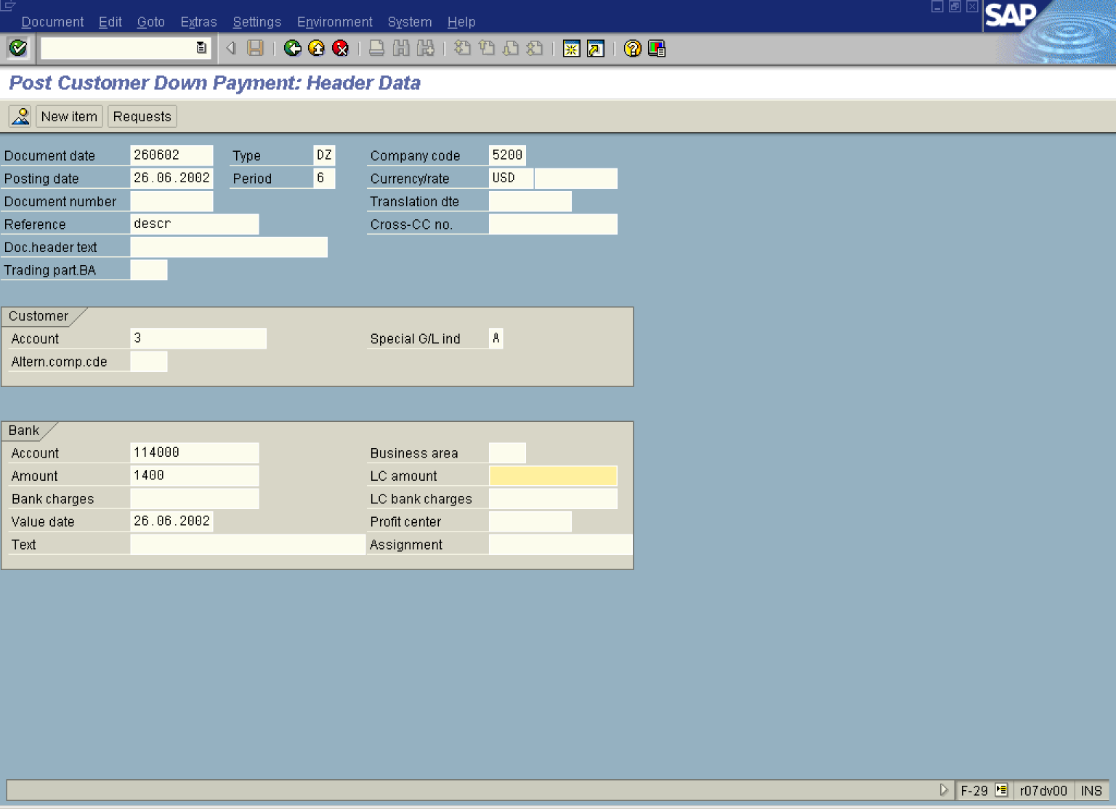

2. Update the following fields:

Field Name | Field Description | Values
Document date | Date the transaction occurred | Example: 260602
Type | Document type code | Example: DZ
Company code | Code identifying a separate legal entity for which a separate set of accounts is maintained for external reporting purposes | Example: 5200
Posting date | Date that the business transaction occurred | Example: 260602
Currency/rate | Code identifying the currency used in the transaction | Example: USD
Reference | Additional document description | Example: descr
Account | Code identifying the General Ledger, Vendor, or Customer account | Example: 3
Special G/L ind | Special GL transaction code | Example: A
Account | GL account (bank account) | Example: 114000

Note: You can enter the line items for the down payment, but it also possible to use previously entered down payment request as a reference:

3. Click Requests Button to display requests entered for this client:

Post Customer Down Payment: Choose requests

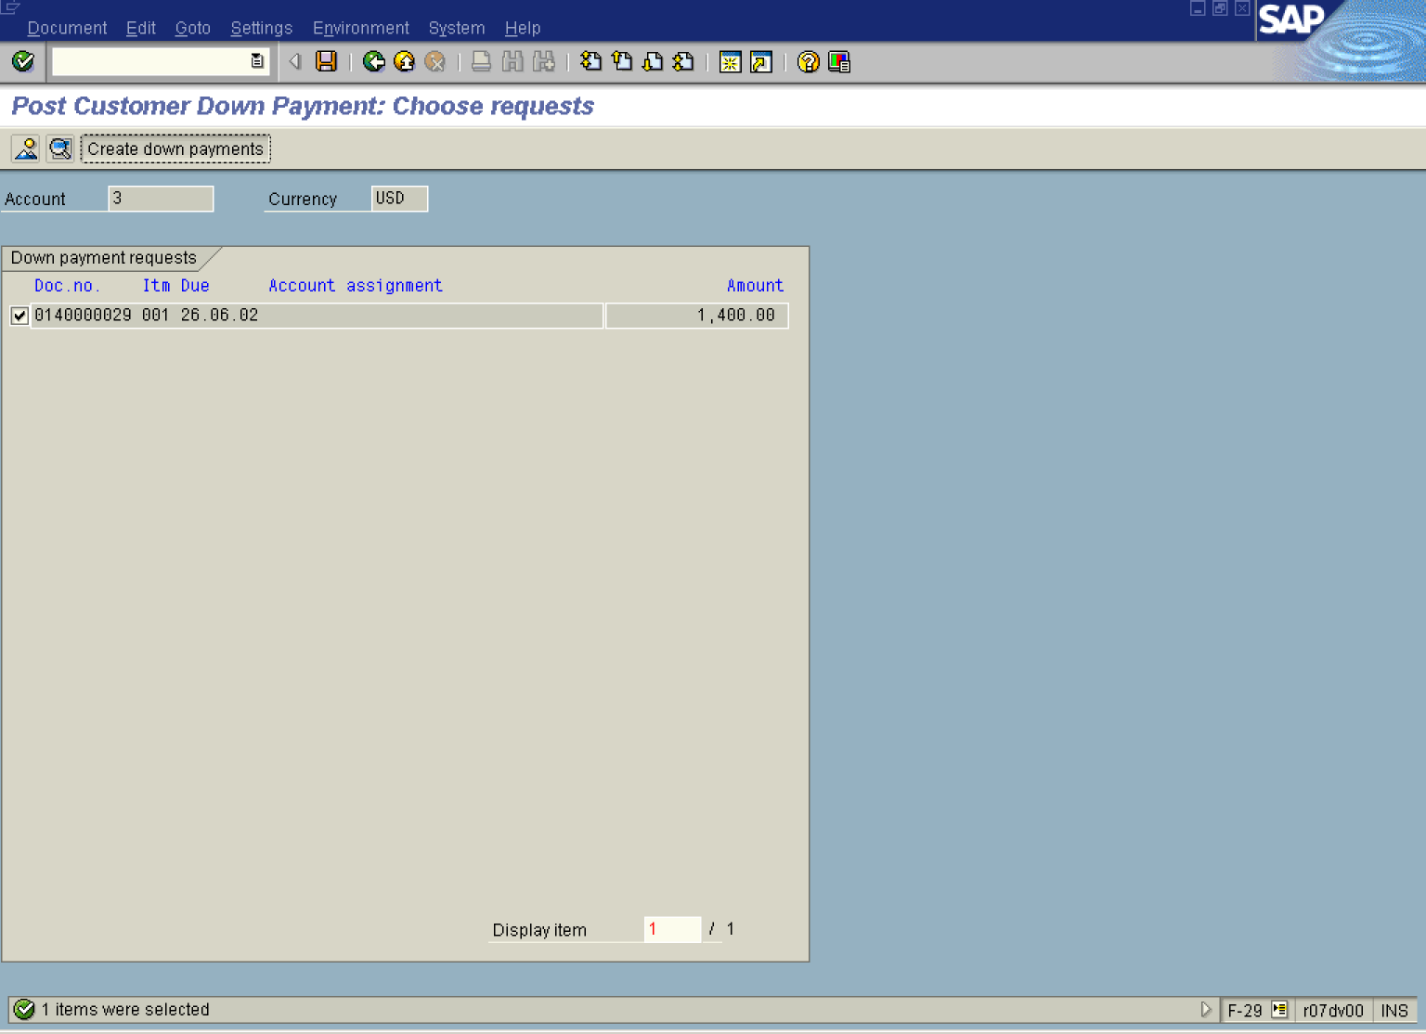

4. Click radio button to mark this payment request to be processed.

5. Now click Create down payments Button .

Note: The system automatically created a down payment, taking payment request as a reference.

Post Customer Down Payment: Display Overview

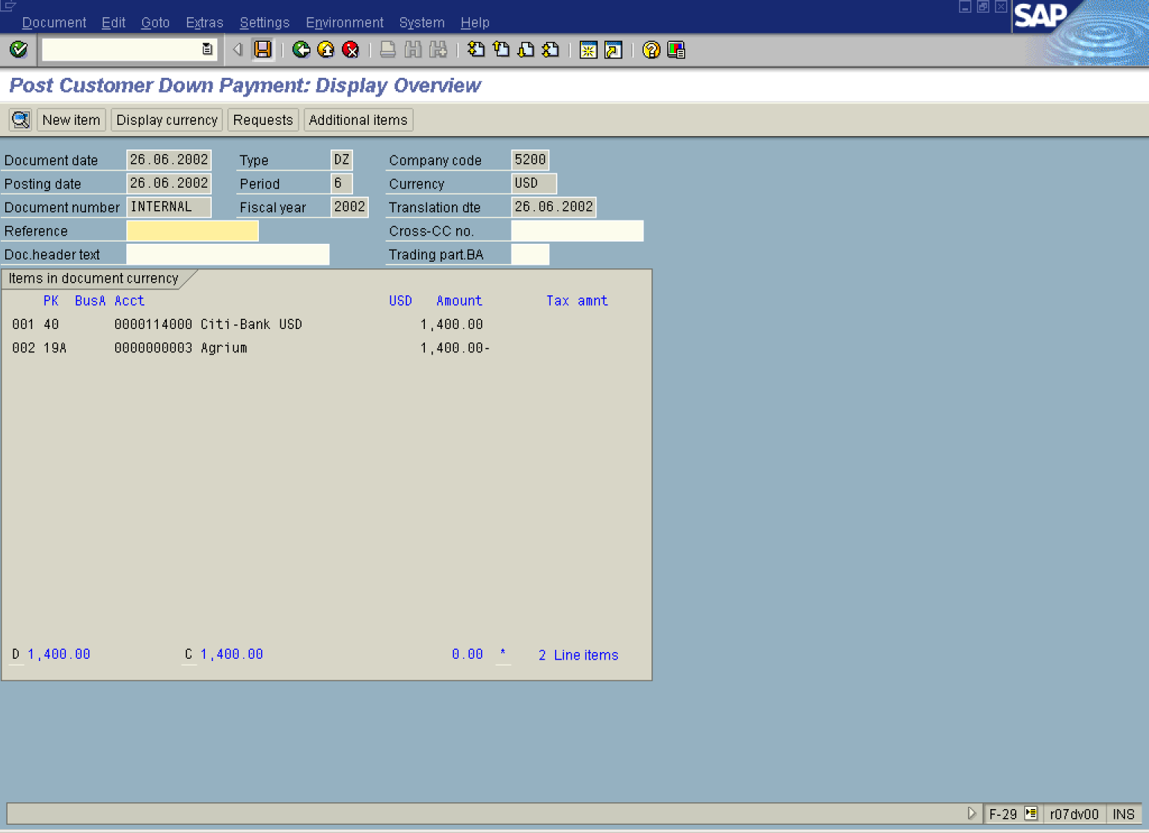
6. Click Save Button. to post the down payment.
7. The message bar displays Document XXXXXX was posted in company code 5200” ”.
Note: Please notice that during this operation not only the down payment was posted. The system also cleared a down payment request, so on the customer account there’s no only one open item: down payment with special GL indicator “A”.

